Daniel Williamson

Jordan Wisnoski

Lab #1 Drawing Blocks

2/2/16

1) Understand the Problem

Create a program to that creates a frame and draws blocks at the base of it in a preordained manner. Like the game of “Tetris”. We must use the G2Graphic to properly implement the uses of this class.

2) Planning

The most difficult portion of our planning phase was figuring out what the coordinates for each shape was supposed to be, and after that we knew that all we had to do was to change the color of the pen and fill the shape we created. Prior to that was understanding how to import different classes from java.

3) Implementation and Testing

Here is our class for creating the frame needed, named Tetris:

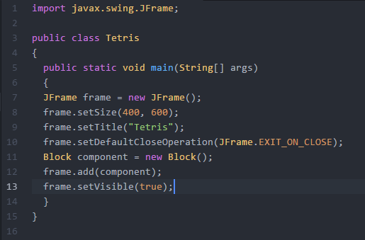

Here is our class for drawing the blocks into the frame created from our Tetris class: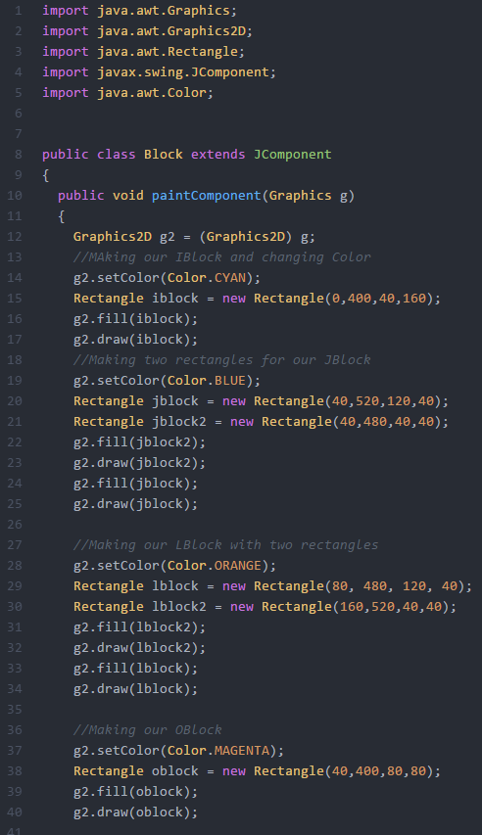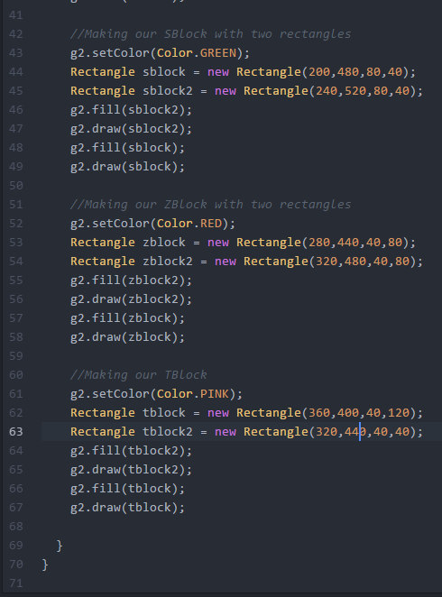

Here is our code complied using MinGW with zero errors:

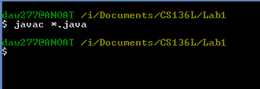

And finally here is our code running:

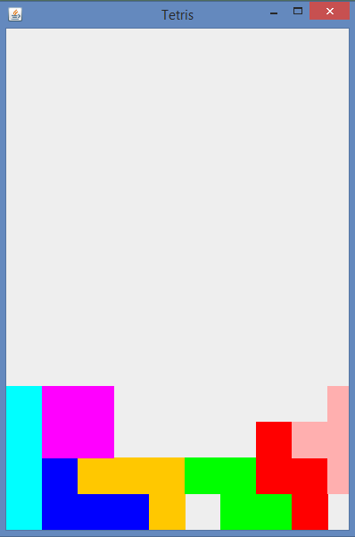

In the beginning it was very rocky as both my partner and I were new to Java. We used the text book extensively. Thankfully the code provided gave us the frame needed for drawing our blocks, we just needed to adjust the size of it, and we named this Tetris. We then created another class in another file for drawing our blocks into the frame, named Block. We needed to import a few components such as Graphics, Graphics2D, Color, Rectangle and JComponent. After creating our first block and positioning it just right we began to get the hang of it. For majority of the blocks created we needed to use to rectangles in order to complete the non-rectangle shaped blocks, like the L-block, J-block, S-block, Z-block and T-block.

4) Reflection

Like stated earlier the beginning was rocky. Once we got the hang of Java and creating the blocks it began to become easier. Something we could have done better was to import polygons to create the non-rectangle shaped blocks instead of using two separate blocks as I imagine if you were to actually turn it into a Tetris game those blocks would need to move as one. As for the rest of the code I believe we did fairly well in making it as efficient as possible. It was a very straight-forward and simple lab. Our inexperience in Java syntax made it more difficult.